**To:** Travel Agency Management *(Word count: 283)*

**From:** Sari Prince, Emily Overall, Navneet Sunderraman, Joshua Noorily

**Subject:** Exploratory Data Analysis of Travel Agent Data

**Date:** 30 September 2023

This summary reports on past booking patterns and sales trends to serve as a foundational step toward formulating effective strategies to revitalize and boost sales.

**EXECUTIVE SUMMARY**

**Major Finding(s)**

England is an ideal target for market expansion. While trips here made up only 0.1% of the total compared to other locations, they earned over twice the revenue of all other trips. (Exhibit 1.1) New Zealand, Russia, and the Seychelles are popular destinations within the top 10 highest commission trips. (Exhibits 1.2-1.3) Freshwater (Other) trips to New Zealand, Russia, and Norway earned the highest commissions, while Wing Shooting trips earned the most in England, Denmark, and Paraguay. (Exhibit 1.4) Nearly half (47%) of all trips are booked between October and December, 63% of trips start between May and September, and 75% of trips last 8 days or less. (Exhibits 1.5-1.7) Finally, only 2% of customers return to book a second trip with the agency. (Exhibit 1.8)

**Recommendation(s) for Action**

The Travel Agency should focus on Sale Enhancements and Promotional Efforts. Sale enhancements include options such as Referral Packages, Seasonal Packages, and a Loyalty Program to increase return rate. For Promotional Efforts, teams should focus on marketing campaigns during the peak booking season, such as specialized perks or discounts for the destinations that historically have high commission rates to increase the amount of bookings to those destinations.

**Analytical Overview**

In our analysis, we first looked at each individual variable; next, we started to combine and cross-reference each variable to look at the complete picture. We wanted to understand which types of trips, countries, or destinations were generating the most income. Not only did we consider what was most profitable, we also considered what types of trips customers are currently booking the most, when they are booking, and when the trips take place.

**Documentation Page**

**Total Trips by Country (Exhibit 1.1):**

|  |  |  |
| --- | --- | --- |
| **Country** | **Number of Trips** | **Percentage Total** |
| AFR | 23 | 0.13% |
| ARG | 2851 | 16.69% |
| AUST | 18 | 0.11% |
| AW | 1398 | 8.18% |
| BAH | 1587 | 9.29% |
| BB | 187 | 1.09% |
| BLZ | 1098 | 6.43% |
| BOL | 161 | 0.94% |
| BRA | 213 | 1.25% |
| CA | 577 | 3.38% |
| CAN | 170 | 1.00% |
| CHI | 453 | 2.65% |
| CI | 305 | 1.79% |
| CR | 46 | 0.27% |
| CZH | 3 | 0.02% |
| DEN | 46 | 0.27% |
| ENG | 16 | 0.09% |
| EUR | 89 | 0.52% |
| Euro | 4 | 0.02% |
| Fran | 15 | 0.09% |
| Guat | 95 | 0.56% |
| ICE | 709 | 4.15% |
| MEX | 1215 | 7.11% |
| MISC | 401 | 2.35% |
| MONG | 49 | 0.29% |
| NEW | 341 | 2.00% |
| NOR | 363 | 2.13% |
| PAR | 32 | 0.19% |
| RUS | 1686 | 9.87% |
| SA | 670 | 3.92% |
| SCOT | 59 | 0.35% |
| SEY | 569 | 3.33% |
| SPA | 69 | 0.40% |
| URU | 568 | 3.33% |
| US | 909 | 5.32% |
| VAR | 87 | 0.51% |
| TOTAL | 17082 | 100% |

**Top 10 Commissions by Country (Exhibit 1.2):**

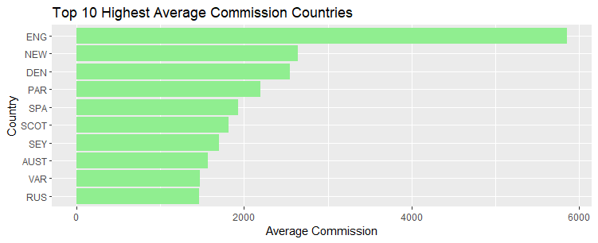

**Top 10 Commissions by Destination (Exhibit 1.3):**

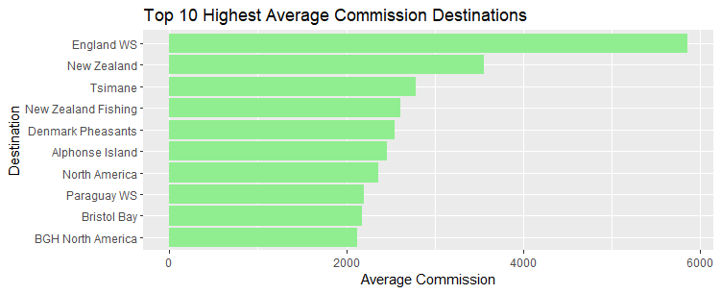

**Highest Commission Countries (Exhibit 1.4):**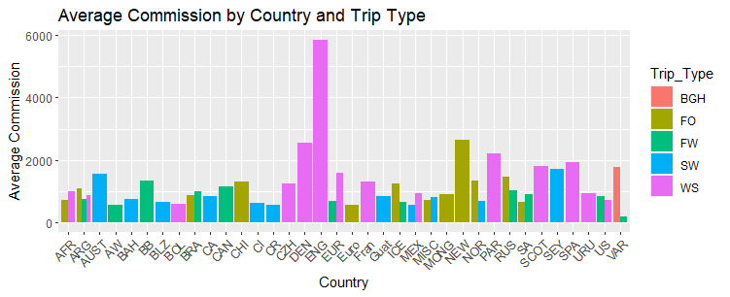

**Season Data (Exhibit 1.5):**

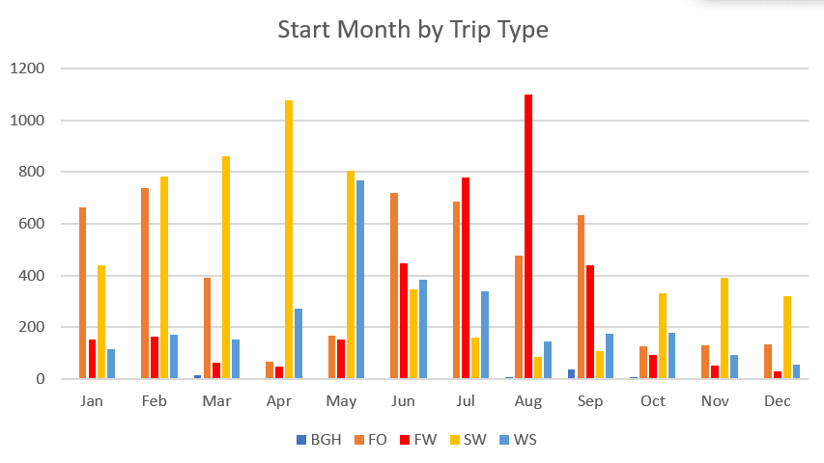

|  |  |  |  |  |  |  |
| --- | --- | --- | --- | --- | --- | --- |
|  | **BGH** | **FO** | **FW** | **SW** | **WS** |  |
| **Jan** |  | 663 | 153 | 439 | 116 |  |
| **Feb** |  | 737 | 163 | 781 | 172 |  |
| **Mar** | 13 | 391 | 62 | 863 | 151 |  |
| **Apr** | 2 | 67 | 48 | 1078 | 272 |  |
| **May** |  | 168 | 152 | 805 | 768 |  |
| **Jun** | 1 | 720 | 448 | 347 | 383 |  |
| **Jul** |  | 685 | 779 | 159 | 338 |  |
| **Aug** | 8 | 478 | 1101 | 85 | 145 |  |
| **Sep** | 37 | 632 | 441 | 109 | 175 |  |
| **Oct** | 8 | 125 | 91 | 333 | 178 |  |
| **Nov** | 1 | 131 | 53 | 392 | 94 |  |
| **Dec** |  | 135 | 31 | 319 | 56 |  |

**Booking Data (Exhibit 1.6):**

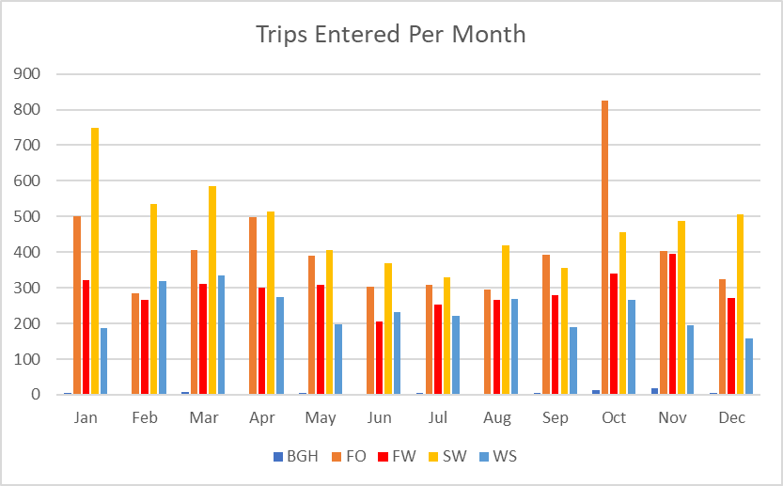

|  |  |  |  |  |  |
| --- | --- | --- | --- | --- | --- |
|  | **BGH** | **FO** | **FW** | **SW** | **WS** |
| **Jan** | 6 | 502 | 322 | 749 | 188 |
| **Feb** | 1 | 285 | 266 | 536 | 318 |
| **Mar** | 8 | 405 | 310 | 584 | 336 |
| **Apr** | 2 | 497 | 300 | 514 | 275 |
| **May** | 4 | 391 | 309 | 405 | 198 |
| **Jun** | 3 | 304 | 205 | 370 | 231 |
| **Jul** | 4 | 308 | 254 | 329 | 221 |
| **Aug** | 2 | 296 | 267 | 419 | 270 |
| **Sep** | 4 | 393 | 280 | 355 | 189 |
| **Oct** | 14 | 824 | 341 | 455 | 267 |
| **Nov** | 17 | 402 | 396 | 488 | 196 |
| **Dec** | 5 | 325 | 272 | 506 | 159 |

**Average Trip Length (Exhibit 1.7):**

|  |  |
| --- | --- |
| **Summary of Trip Length** | |
| Statistics | Value |
| Range | 377.00 |
| IQR | 3.00 |
| Variance | 67.30 |
| Standard Deviation | 8.20 |
| Coefficient of Variation | 108.92 |
| Mean | 7.53 |
| Median | 7.00 |
| Q1 | 5.00 |
| Q3 | 8.00 |
| Mode | 7.00 |

**Client Churn Rate (Exhibit 1.8):**

